Overview of Estimating
Estimating is the ability to make an educated guess as to the duration, work or duration and work of a task. It is an art to know how long a task will take and how manyresources are required and of what skills are required for a task.
How Project 2010 defines and calculates Work and Duration
It would be helpful to understand the formula that will be driving the scheduling of the tasks before you enter your estimates:
Work = Duration * Units (quantity of a resource)
OR
Duration = Work / Units (quantity of a resource)
Estimating techniques
Top down estimating: used when performing the same types of projects frequently. Top-down estimating allows for estimating the length of a phase. The details for tasks will follow. Manual scheduling mode in Project 2010 allows for this type of estimating model.
Bottom up estimating: estimating each task work package or deliverable of the project (this could be at the task level) will allow for the accumulated roll up of the values to create the length of the project. The roll up will accumulate at the summary task levels as totals for duration, work and cost. In turn, the summary tasks will roll up to the project summary task for a grand total for the project.
What to estimate?
Estimate duration (length of time) in minutes, hours, days, months, etc.
Estimate work (amount of work) in minutes, hours, days, months, etc.
Estimate duration and work in minutes, hours, days, months, etc.
Where do the estimates come from?
Estimates may come from the project manager, team members, subject matter experts, stakeholders, historic data, experience, etc.
How do you get good estimates?
Ask the right people: look for the most experienced person in a specific skill area. Chances are, they have worked a project similar to or have actually performed the work in the past. These types of people can be invaluable to a project manager for estimating.
Ask the performing resource: if you are lucky enough to know who your resources will be for the project, the performing resource is always the best source for an estimate. However, how you ask the resource for the estimate will make a difference. If you ask for an estimate, most people are thinking about fitting the work into their current workload. Framing the question from the point of view that the project will be worked some time in the future will result in a more accurate response. They should only consider how long (or how much work) it would take to perform the task regardless of the specific timeframe.
Ask more than one person: seeking various points of view for estimates will help define what the best estimate is. Project 2010 has an add-in feature called PERT which allows for 3-point estimates for task durations. The 3 points are pessimistic, most likely and optimistic. These values are feed into a formula that will result in an estimated duration of a task. The result will be three Gantt Charts: Pessimistic, Optimistic and Most likely.
Subject Matter Experts: always a good source for advice.
BEST PRACTICE: Padding, slack, and time reserve should be included in any schedule. Every organization and project management methodology has its own approach. The important point is that extra time should be built into all schedules to help manage the inevitable contingencies that will occur during the performance of all projects. If padding, slack or time reserves are not included in the planning, the schedule will not be realistic and will result in a reduced probability of completing the project as planned.
Entering Estimates
The Entry table of the Gantt chart is designed for easy entry of task estimates. Adding the work column to the view will enable adding Work estimates.
To insert the work column in to the Entry table of the Gantt Chart view:
Tasks → Gantt Chart (the default value will be the Entry table)
Right click on the column heading Start
Select Insert Column
Click on the “W” key on the keyboard
Click on Work
Click OK to close the box
For each task enter:
A duration value
A work value
A duration and a work value
Valid entry values:
1m = 1 minute
1h = 1 hour
1d = 1 day
1w = 1 week
1mo = 1 month
1 y = 1 year
Abbreviations of the time values may be customized in the Schedule options:

File → Options → Schedule
Duration entries will be scheduled as work days as defined by the project calendar.
Physical days (actual day count including non-working days) may also be achieved by using the Elapsed time. By placing an “E” in front of the letter in the duration field, the value will be scheduled in physical number of days. For example: 13 ed = 13 physical days.
In the example below, Task 1 is scheduled as business days (using the project calendar) and Task 2 is scheduled as physical days. Note the scheduling difference:
PLACEHOLDER
Other helpful information:
When task durations are entered, a “?” will be added within the duration field. This “?” represents that the task information has not been finalized and considered estimated. This indicator is optional and may be turned off at File → Options → Schedule and un-checking the following options:
Show that scheduled tasks have estimated durations
New scheduled tasks have estimated durations
Some project mangers plan all tasks in fixed duration. It should be noted, that fixed duration tasks will be tied to calendar dates and might be more difficult to schedule and track in the future.
Manual scheduling mode for a task has the benefit of not requiring values in duration, start and finish columns. Text may be added as a note to the scheduler. If the task mode is changed to automatic scheduling, the text will be lost and, the software will enter a valid values. Scheduling modes will be discussed in Module 4. In the view below note the values in the duration, start and finish columns for Task 2:
PLACEHOLDER
Inserting Effort-driven and Type columns will allow for setting these values for each task as well. As discussed in Module 2, each task will be unique in the nature of the work to be performed. As a result, these settings should be adjusted to determine what task type and effort-driven values are appropriate for a task.
Estimating for Unknown Resources
Most project managers plan the work for a project and find out what specific resources will perform the tasks in the future. Tasks might require a specific skill level but the quality of the unfamiliar resource is unknown. How do you plan for unknown resources?
When estimating tasks, consider estimating a task for a senior level resource or a junior level resource:
The senior level person would accomplish the task faster and would cost more.
The junior level resource would cost less but needs more time and training.
Outsourcing resources: although there is a quantity of highly qualified contract resources, the recommendation is to estimate these tasks at the junior level. You will need to account for learning curve, assimilation into your organization and ramp up. The project manager might request a specific skill level but it is unknown whether or not that skill will be available when the project requires it.
As mentioned earlier, the PERT estimating method could give a 3 point duration estimate. Using PERT will result in 3 different reports; an optimistic Gantt Chart, a pessimistic Gantt Chart and an expected Gantt Chart. The PERT estimating module is an add-in in Project 2010 and is available at no cost as a download from Microsoft.
Add Elaspsed Time

Duration, Work, or Duration & Work

Types of Durations

Concept of the Scheduling Engine
Dynamic scheduling is the use of task relationships and dependencies to drive the sequence and ultimately the timing of the schedule. Project’s scheduling engine support dynamic scheduling.
This means that as you make adjustments to certain tasks as the project progresses Project automatically recalculates the effect on subsequent tasks. This will also show the project manager if the overall schedule is extended and provide analysis opportunity to monitor if the change creates multiple critical paths, potential resource constraints, and so on.
Project will also highlight those tasks affected by a change so the project manager can easily see the ripple effect of the current proposed task changes. With the 99 levels of undo in Project 2010, a project manager can also utilize this highlighting feature to conduct Monte Carlo, or What If, analysis to analyze multiple scenarios of task adjustments to the schedule.
If constraints are utilized to lock in task dates this disables Project’s built-in scheduling engine and a project manager will not be able to see the effects downstream in the schedule. Maintaining this dynamic visibility is vital in effectively and proactively managing a schedule. This is why it is a best practice to not use constraints, unless necessary and appropriate to the task.
Linking
Task Dependency Types
Project 2010 allows for 4 types of task dependencies. These dependencies establish the order that the tasks will be performed. Dependencies may also be referred to as links, relationships or relationships between tasks. The result of creating task relationships is a network of related tasks establishing a time line. When referring to linked tasks the following terms will apply:
A task that has a relationship directly before a task is known as a predecessor task
A task that has a relationship directly after a task is known as a successor task
In the view below there are 4 tasks. The relationships are established as link lines between tasks.
The predecessor task or task that comes before Task B is Task A.
The successor task or task that comes after Task B is Task C.
Pointing to a link line between tasks will reveal information regarding the relationship between tasks. See the highlighted box below which is showing the details of the relationship between Task C and Tack D.
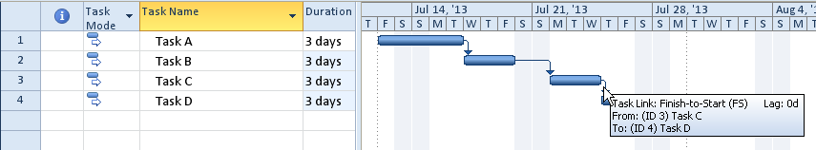
PLACEHOLDER
Not all dependencies are the same. Some tasks will start at the same time where others might be schedule one after the next. To facilitate scheduling needs, there are 4 dependency types which are:
Finish-to-start
Start-to-start
Finish-to-finish
Start-to-finish
The details of each of the relationship types is described below:
Finish-to-Start (FS)
Default dependency for the Project 2010
Task 1 must complete before Task 2 can begin
This relationship type creates a waterfall effect
Example: Drive to the restaurant, then eat dinner
Build a wall then paint the wall
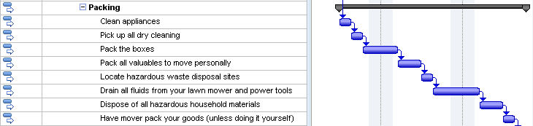
PLACEHOLDER
Start-to-Start (SS)
Tasks that are scheduled to start at the same time
Example: After the moving expenses are calculated, then determining the best moving method, create a moving-expenses file and create a moving binder may all start at the same time. All 3 tasks should be completed (in this example) to pass the milestone and move on to the next section of work. It should also be noted that the 3 tasks that are starting at the same time are not scheduled to complete at the same time. As a result, the longest task will determine when the milestone will be scheduled.
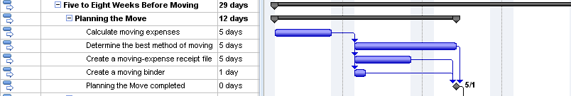
PLACEHOLDER
Finish-to-Finish (FF)
Tasks that are scheduled to finish at the same time but not required to start at the same time.
Example: The section of work below can all start when the previous section is completed. These tasks will start at different times, but they all need to be completed by the same point in time.
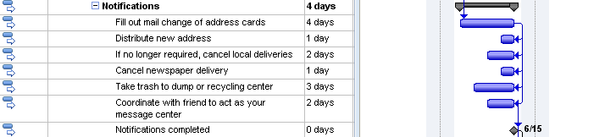
PLACEHOLDER
Start-to-Finish (SF)
The start date of the predecessor task will determine the finish date of the successor task.
This is the least used dependency type and rarely used.
Example: When the new software module comes on line, the old software will be taken off line
When working with manually scheduled tasks, errors might result using dependencies. A warning is viewed when tasks are linked and dates are entered into the start or finish columns. The calculation of the project duration might not match the duration calculated when the entered dates are taken into consideration. Below is an example of an error created when a date was entered in the start column for Task B. The error is represented by the red line under the incorrect date and the dots around the Gantt bars.
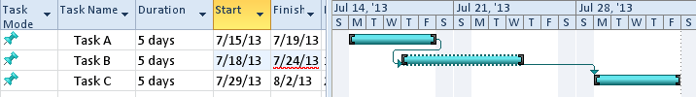
PLACEHOLDER
To correct this type of error, Project 2010 has a new feature called Respect Links. Right click on the red error line and following choices appear. Select the Respect Links option and the date will be recalculted based on the task relatioships.
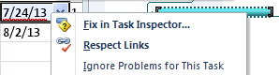
PLACEHOLDER
Below is the result of clicking on the Respect Links option for the task. Note the error message is no longer visable and the task in error has been rescheduled.
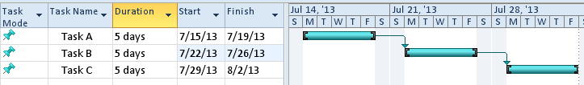
PLACEHOLDER
Best Practices for Using Dependencies
Project 2010 calculates the duration of a project based on how task dependencies are created between tasks. Establishing the order of the tasks is called Sequencing. Sequencing is concerned with establishing the order tasks should or could be performed. Arranging tasks in the most efficient order for the project is not an easy exercise. Sometimes, the order of the tasks is very evident and at other times, more complicated. Sequencing is more option than right or wrong for a project.
For example, the following tasks are tasks that someone would do when they come home after work and before they go to bed:
Arrive Home
Eat Dinner
Walk the dog
Run an errand
Read the mail
Clean up the dinner dishes
Cook dinner
Go to Sleep
Get the mail
Watch the news
Take a minute to write down the numbers of the tasks above in the order you would perform these tasks.
Things you might notice:
You will have some forced relationships:
You can’t eat dinner until you make dinner
You can’t read the mail until you get the mail
You will also notice that Arrive Home and Go to Sleep are the start and finish of the sequence.
Some tasks can occur at any time and are not dependent upon another tasks
Some tasks you might consider doing differently, like picking up dinner on the way home. It would accomplish the same purpose and save time.
Can any tasks be done at the same time as other tasks to save time?
Should any tasks be eliminated?
Next rework this same sequence of tasks knowing that someone else will help perform the tasks. Does it turn out differently? Would it take less or more time? Some tasks you have to do yourself and some tasks can be performed by someone else.
Best practices to consider when creating dependencies:
Relationship between tasks will allow you to create network of related tasks. The network will show order the tasks will occur. Below are some best practices which should be considered when creating relationships:
All tasks should have both a predecessor and a successor. The timeline for the project is based on this concept. If tasks are not linked in the network of tasks, their duration will not be accounted for within the timeline. Making sure all task durations are accounted for will avoid surprises at the end of a project.
When creating dependencies or relationships, apply the rule – because I can, is it a good idea? Do not link every task to every other task. In the example above, should you should have linked Arrive Home with Go to Sleep with the logic of if you don’t come home, you can’t go to sleep? The answer is no. Only the last task that is completed before Go to Sleep should be linked to Go to Sleep.
Think about what task pushes or influences another task. If a task is late, what other tasks will be affected? Link only tasks with a direct affect on a successor task. Ask yourself what needs to be completed before you can do the next step and if it is late, which tasks will be affected.
Link detailed tasks and milestones only. The completion of tasks will push the milestones or the short term goals. Linking summary tasks means that an entire section of work must be completed before the next section may be started. Ask yourself if that is true for your situation before linking at the summary level. Linking summary tasks is not recommended.
Tasks should always be linked to push milestones. For example: define what the definition of “project completed” is. The multiple parallel paths that must be completed to conclude the project should all be linked to the ending milestone. If any of the parallel paths take longer than planned, the milestone date will be pushed out in time.
In the example below “Start the Project” is the starting milestone. The next 3 sections of work all start when the project starts. All 3 sections must be completed before the house is ready to sell. If any of the sections take longer, each section has the ability to push the ending milestone or when the house is ready to sell. The longest of the parallel paths will be considered the critical path or the section that determines the timeline of the project.
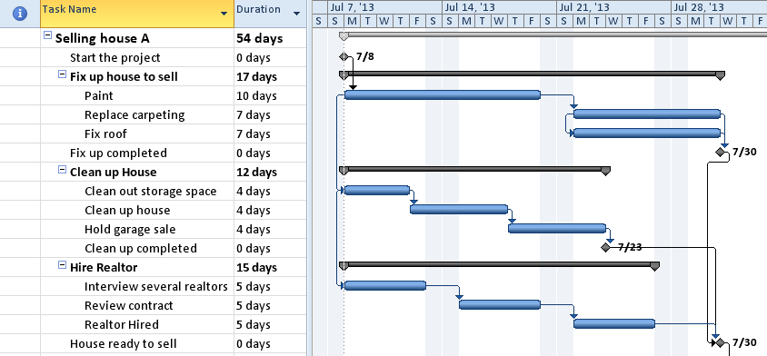
PLACEHOLDER
Create as many parallel paths as possible to shorten the schedule. Use of the Start-To-Start and Finish-To –Finish relationships will help create parallel paths and shorten the project time line. Be aware, however, just because you can schedule tasks in parallel, you might not have the resources to perform the work and which could extend the timeline.
Do not link tasks based on a resource. Some people will plan tasks to occur at specific times because they think that a resource will be available at that time. Chances are the expected resources will not be available at the planned point in time because other tasks for that resource have changed. Plan the schedule for the work required and plan/arrange for required resources as the time draws nearer to when the task will be performed.
Links may be external to the project. Project 2010 will allow dependencies to exist in other projects that are linked to tasks in your project. This is similar to links in Excel. In Excel, if links between files are created and the files are relocated, the links will be broken. Project 2010’s links between project files will work the same way.
Project 2010 also offers the option for tasks that are moved or added to the schedule to automatically link in a Finish-to-Start relationship or not be linked at all. This is a personal preference and may be applied to a specific project or all projects viewed on your desktop.

To view or change this option: File → Options → Schedule
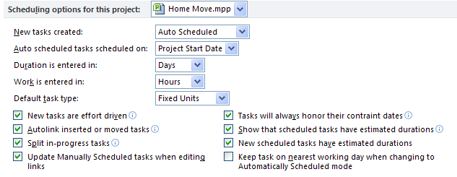
PLACEHOLDER
Lead & Lag
Relationships between tasks are not always absolutely defined as described with relationships. Allowing for Lead and Lag time will help refine a schedule to bring it more in line with the actual timeline for the project. Lead and Lag time will allow for wait time between tasks and overlap of task activities.
In this Lesson we will discuss:
What is Lag time?
What is Lead time?
Best Practices for using Lead and Lag time
What is Lag Time?
Lag time is used to provide wait time between tasks. The time will be expressed in business days or valid project calendar working time. Lag time should be used to extend the timeline of the project when only duration needs to be added to a schedule and will not add work or cost. For example: New concrete is poured and you must wait 6 days before you can drive on it. The time must occur but no work or cost is added to the task. A dependency must first exist between tasks before Lag time can be created.
To create Lag time:
Double click the relationship line between tasks where you would like to add the lag time. The task dependency dialog box below will appear. In the illustration below, we see that there are 2 tasks. After the equipment is ordered there will be a 2 week delivery wait time before the equipment is received. To create this wait time, set the Lag field to 2w (2 weeks). Click OK.
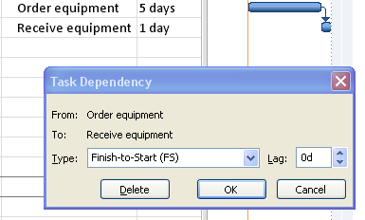
PLACEHOLDER
The result is of adding a 2 week lag shown in the illustration below.
PLACEHOLDER
An alternate method of entering lag time is by adding the value of the lag into the predecessor column as shown below:
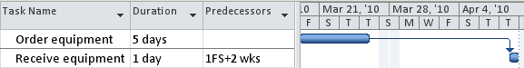
PLACEHOLDER
Lag time may also be expressed as a percentage of the duration of the predecessor task. Order equipment is a 5 day task. 50% Lag would mean that the length of the lag time would be 2.5 days or half of the 5 days duration of the Order equipment task.
What is Lead Time?
Lead time shortens the time line of the project. Consider tasks that do not need to be 100% completed before the successor task can start. Lead time is a good tool to help refine the schedule when trying to cut time from a timeline. Project 2010 does not have a field or box called Lead time. Instead, to create Lead time negative Lag time is entered.
To create Lead time:
The diagram below allows 10 days to unpack equipment and 10 days to set up the equipment. The same resources are performing both tasks. The 2 tasks together will require 20 days to complete if the equipment was set up after all of the equipment has been unpacked. If you had more resources to work on the tasks could you get these tasks accomplished quicker? In the example below the task to set up equipment will be scheduled to start when the equipment is half unpacked.
Below is a view of the tasks before lead time is entered. The tasks are scheduled for 20 days of duration.
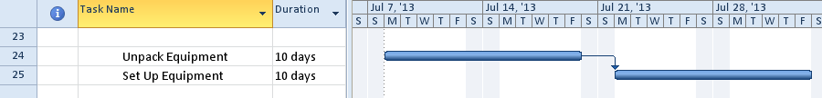
PLACEHOLDER
To enter Lead time between two tasks:
Double click the relationship line between tasks where lead time is to be added.
Enter “-5days” in the Lag field value
Click OK to close the box
The task dependency dialog box shown below will appear.
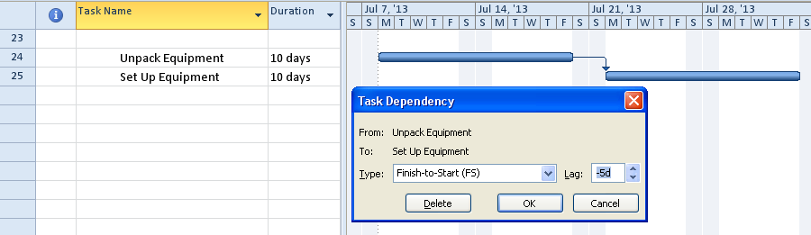
PLACEHOLDER
Below is the result of adding lead time between two tasks. Note the overlap of tasks and the total scheduling time has been shortened.
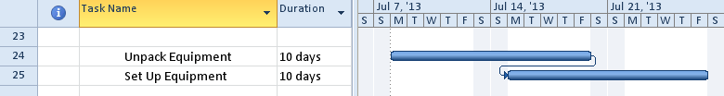
PLACEHOLDER
Lead time can also be expressed in percentages. The advantage to using percentages is if the predecessor task length changes, the successor task will automatically adjust its starting date.
For example:
Task A is 10 days long and has a Finish-to-start relationship with Task B with -50% lead time
Task B will is scheduled to start when Task A has 5 days of work completed
Task A is taking longer than expected and is now scheduled to take 15 days
Task B will be rescheduled to start when Task A has 7.5 days of work completed.
A -50% would move the successor task to the left 50% of the duration of the predecesser task. The diagram below demonstrates the result of applying -50% for Lead time to the relationship between these two tasks.
To enter Lead time between two tasks as a percentage value:
Double click the relationship line between tasks where lead time is required.
Enter “-50%” in the Lag field value
Click OK to close the box
PLACEHOLDER
Best Practices
Use Lag time when extending the timeline without adding cost or work to the project.
Best practices for the use of Lag time in a project schedule:
Time must go by without a work or cost applied to the time. Lag is considered to be wait time like a delivery of equipment or concrete hardening
Adding slack into the schedule to extend the timeline to allow for possible contingencies
Adding wait time between phases of a project
Adding wait time between parallel sections of a project to allow others to catch up
Lag time may also be expressed in elapsed time to allow nights and weekends to be included
Planning the work for a factory crew. For example: the crew needs to be at work for 9 hours but 8 of that is actual work. The remaining hour is meal and breaks. Use Lag to extend the time for the work of the crew to accommodate breaks.
Use lead time when the schedule needs to be shortened. More resources will be needed to accomplish the tasks. Lead time can increase risk of re-work and could increase cost for tasks.
Best practices for the use of Lead time in a project schedule:
Piece work – when X number of items or time has been completed, giving the completed work to the next group to start their work.
Testing – when X percentage of the testing is completed and successful, giving the completed work to the next group to start their work.
When it is not necessary for the predecessor task to achieve 100% completion before starting the successor task.
Inactivate Tasks
When developing a schedule or even after a schedule is being executed, you may have portions of the schedule that may be optional or you may be looking for ways to run a scenario which leaves out a portion of the schedule from the scheduling engine. Choosing to inactivate a collection of tasks is a way to temporarily or permanently remove tasks from the rest of the schedule, but still leave the information about those tasks intact so you can reactivate them at a later time as desired, or keep this inactive data for historical purposes. This feature saves time over having to delete and re-enter task information. All tasks by default are active unless you make them inactive.
This feature is in Project Professional 2010 only.
To inactivate a task:
Select the task(s).
On the Task tab, Schedule group, click Inactivate.
Project Ribbon – Inactivate Task
If you made a mistake and accidentally inactivate the wrong task(s), simply click Inactivate again to make them active.
This feature is especially useful when you are struggling with test/retest cycles. Simply inactivate the extra cycles until they are needed.
Inactive tasks are a great way to include contingency actions which only apply if a planned risk actually manifests itself in the future.

